**Mini Project Report on**



**MULTIMODALITY MEDICAL IMAGE FUSION**



**Submitted in partial fulfilment of the requirement for the award of the degree of**

**BACHELOR OF TECHNOLOGY**

**IN**

**COMPUTER SCIENCE & ENGINEERING**

**Submitted by:**

**Student Name**  **University Roll No.**

**ARTHAM BHARDWAJ 2018718**

***Under the Mentorship of***

**Manoj Diwakar**

**Associate Professor**



**Department of Computer Science and Engineering**

**Graphic Era (Deemed to be University)**

**Dehradun, Uttarakhand**

**July-2023**



**CANDIDATE’S DECLARATION**

I hereby certify that the work which is being presented in the project report entitled **“Multimodality Medical Image Fusion”** in partial fulfillment of the requirements for the award of the Degree of Bachelor of Technology in Computer Science and Engineeringof the Graphic Era (Deemed to be University), Dehradun shall be carried out by the under the mentorship of **Manoj Diwaker, Associate Professor**, Department of Computer Science and Engineering, Graphic Era (Deemed to be University), Dehradun.

Name :Artham Bhardwaj University Roll no: 2018718

**Table of Contents**

|  |  |  |
| --- | --- | --- |
| **Chapter No.** | **Description** | **Page No.** |
| Chapter 1 | Introduction | **1-2** |
| Chapter 2 | Literature Survey | **3-5** |
| Chapter 3 | Methodology | **6-10** |
| Chapter 4 | Result and Discussion | **11-13** |
| Chapter 5 | Conclusion and Future Work | **14-15** |
|  | References | **16** |

**Chapter 1**

**Introduction**

**1.1 Introduction**

Multi-modality medical image fusion is a rapidly evolving field that aims to enhance the quality, information content, and interpretability of medical images by combining data from different imaging modalities. By integrating complementary information from multiple sources, multi-modality image fusion enables clinicians and researchers to obtain a more comprehensive and accurate understanding of anatomical structures, physiological functions, and pathological conditions.

**1.2 Importance of Multi-modality Medical Image Fusion:**

The integration of multiple imaging modalities has gained significant importance in clinical practice and medical research. Each modality offers unique strengths and limitations in terms of image resolution, tissue contrast, functional information, and imaging depth. By fusing images from different modalities, clinicians can leverage the complementary nature of these modalities to overcome their individual limitations and extract the most relevant information for accurate diagnosis, treatment planning, and monitoring of medical conditions.

**1.3 Key Objectives and Benefits:**

The primary objective of multi-modality medical image fusion is to enhance the overall quality and interpretability of medical images. By fusing information from different modalities, the fused image provides a more comprehensive representation of the targeted area, allowing clinicians to visualize anatomical structures, identify abnormalities, and assess functional characteristics simultaneously. This comprehensive assessment improves diagnostic accuracy, facilitates treatment planning, and enhances the understanding of disease progression and treatment response.

**1.4 Challenges in Multi-modality Image Fusion:**

Despite its immense potential, multi-modality image fusion poses several challenges. These challenges include image registration, which involves aligning images from different modalities to a common coordinate system, ensuring spatial and intensity consistency, handling differences in resolution and noise characteristics, and dealing with artifacts introduced during the fusion process. Addressing these challenges requires the development of robust fusion algorithms and evaluation metrics to assess the quality and clinical utility of fused images.

**1.5 Fusion Techniques and Approaches:**

Various techniques and approaches have been proposed for multi-modality medical image fusion. These include pixel-based methods, feature-based methods, and transform-based methods. Pixel-based fusion involves direct combination of pixel intensities from different modalities, while feature-based fusion focuses on extracting relevant features and combining them to create a fused image. Transform-based fusion employs mathematical transforms such as wavelet, Fourier, or sparse representation to merge information from multiple modalities.

**1.6 Applications of Multi-modality Image Fusion:**

Multi-modality medical image fusion finds applications in numerous medical domains, including neurology, oncology, cardiology, and more. In neurology, fusion of MRI and PET scans enables accurate localization of brain abnormalities and improves the identification of tumor margins. In oncology, combining CT and PET images aids in tumor detection, staging, and treatment planning. Cardiac fusion imaging integrates MRI and ultrasound data to assess heart function and diagnose cardiovascular diseases. These examples highlight the diverse applications and potential benefits of multi-modality image fusion.

**Chapter 2**

**Literature Survey**

**The following texts have been surveyed and analyzed for this project:**

**Title:** A Fusion Approach of Multimodality Medical Image with Deep Neural Network

**Authors**: Jian Huang, Yuanyuan Wei, Dongling Liang

**Abstract:** This paper presents a deeply supervised autoencoder structure for multimodal medical image fusion using a deep neural network. The proposed method utilizes nested and dense skip pathways to capture features at different levels, effectively reducing the semantic gap between high-resolution feature maps and up-sampled outputs. By employing an adaptive fusion strategy, the method achieves effective fusion with richer information in the fused image features.

**Introduction:** Medical images play a crucial role in clinical applications, aiding in the diagnosis and treatment of various diseases. These images are often obtained through different imaging modalities, such as PET, MRI, and CT. Image fusion techniques combine complementary information from multiple sources to generate a visualized synthetic image with enhanced functional and textural information. With the development of sensor and computer science, medical image fusion has become an indispensable component in clinical applications and a hot topic in recent years.

**Methods:** The proposed fusion approach utilizes a deeply supervised autoencoder structure. The encoder network extracts deep features from the source images using convolutional layers and dense blocks. The fusion blocks employ an additive fusion strategy to combine the extracted deep features, resulting in a fused feature map. Finally, the nested and dense connected decoder network reconstructs the fused image.

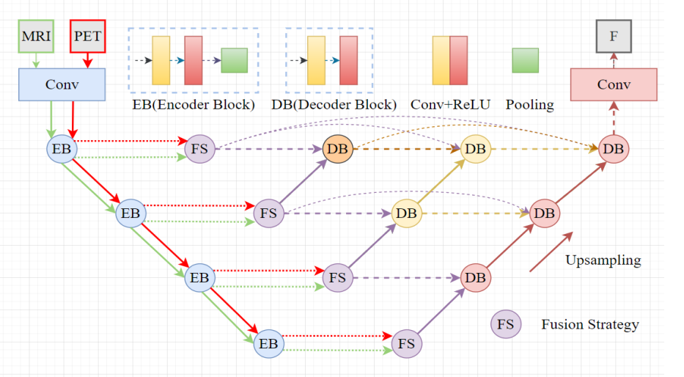

**Fig 2.1 : The Main Architecture of Proposed Method**

**Results and Analysis:** The method was evaluated using 20 pairs of multimodal medical images. Several state-of-the-art fusion algorithms were compared to validate the effectiveness of the proposed approach. Seven quality metrics, including entropy, mutual information, average gradient, spatial frequency, correlation coefficient, standard deviation, and peak signal-to-noise ratio, were used for quantitative evaluation.

The experimental results demonstrated that the proposed method outperformed other fusion algorithms in terms of correlation coefficient, achieving the highest values for 2, 9, 15, 16, and 20 test objects among all 20 pairs of test images. Visual comparisons also showed that the proposed approach preserved a significant amount of texture details and functional information from the source images, resulting in superior fusion results.

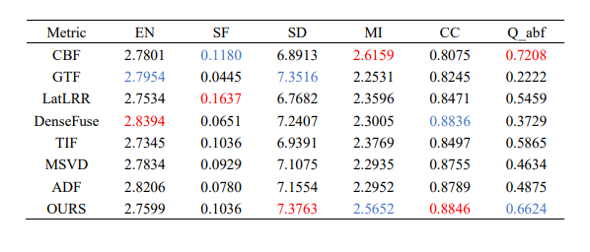

**Fig 2.2: Average of Existing Fusion Algorithms**

**Conclusion:** The fusion approach using a deep neural network with nested and dense skip pathways proved effective for multimodal medical image fusion. The method exhibited excellent fusion results, retaining substantial information from the source images. The proposed technique's ability to automatically extract features from the source images eliminates the need for manual design, making it a promising approach for future medical image fusion applications.

**Chapter 3**

**Methodology**

Multi-modality image fusion refers to the process of combining images obtained from different imaging modalities, such as computed tomography (CT), magnetic resonance imaging (MRI), positron emission tomography (PET), ultrasound, and others. The goal of multi-modality image fusion is to integrate the complementary information from these modalities into a single fused image, which provides a more comprehensive and enhanced representation of the underlying structures or functions being imaged.

**3.1 STOPS INVOLVED:**

**3.1.1**

**Image Acquisition:**

* + The first step is to acquire medical images from different modalities, such as CT and MRI. These images serve as the input for the fusion process. It is important to ensure that the images are properly calibrated and aligned to a common coordinate system for accurate fusion.

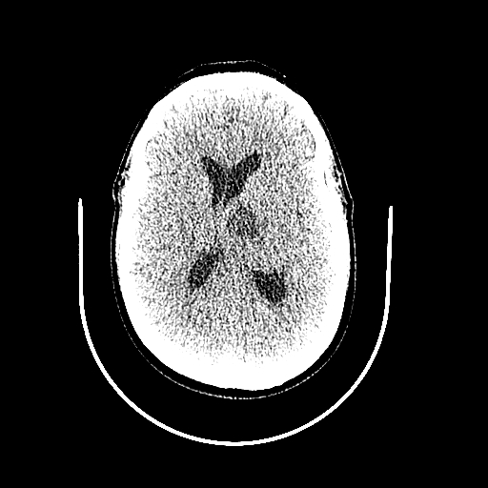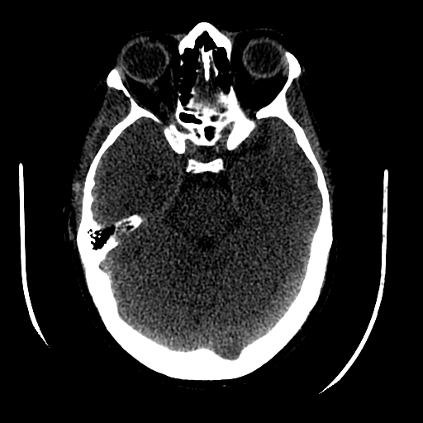

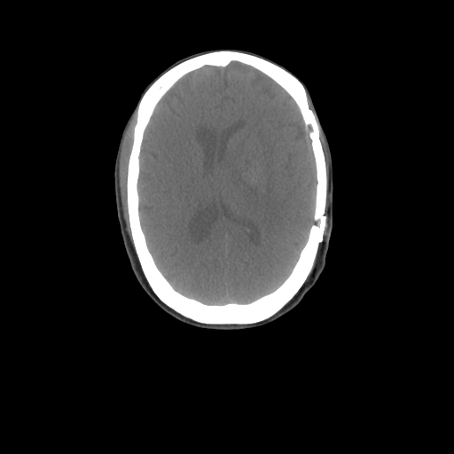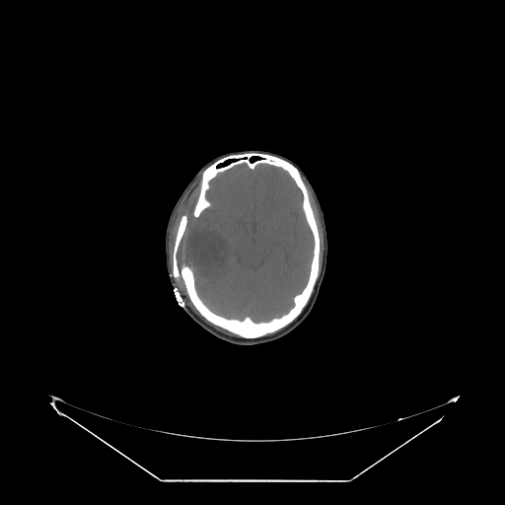

**Fig 3.1: CT Scans of patients**

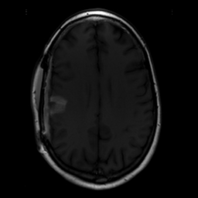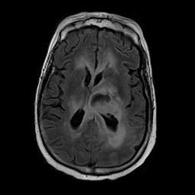

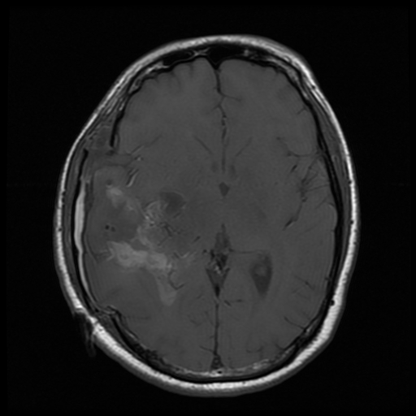

**Fig 3.2: MRI Scans of Patients**

**3.1.2**

**Preprocessing:**

* + Preprocessing is performed on the acquired images to enhance their quality and remove any artifacts or noise. Techniques like denoising, intensity normalization, and spatial registration are applied. These steps help in improving the overall quality and alignment of the images.

**3.1.3**

**Image Registration:**

* + Image registration is a crucial step that aims to align the acquired images spatially. It involves finding a transformation that aligns the images accurately. In the provided code, the Procrustes analysis method is used for image registration. It calculates the optimal rotation, scaling, and translation parameters to align the images.

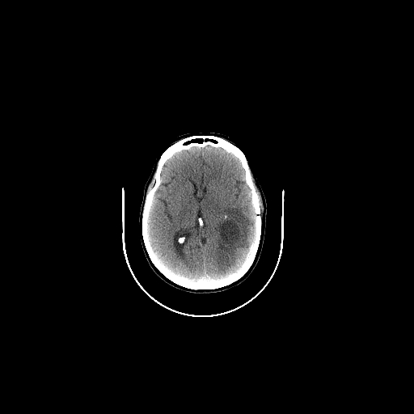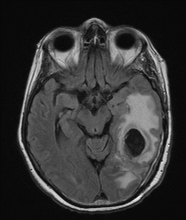

(a) (b)

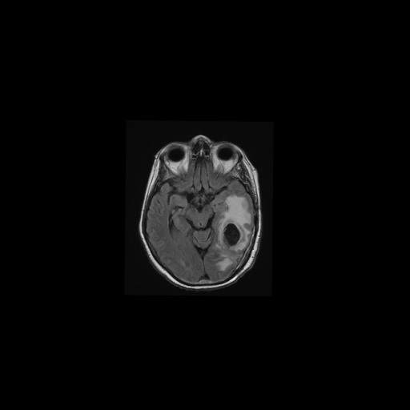

(c)

**Fig 3.3: a) CT Scan b) MRI Non Registered Image c)MRI Image resgistered to size of CT scan image**

**3.1.4**

**Fusion Techniques:**

**3.1.4.1 Pixel-Based Fusion:** - Pixel-based fusion is a simple and intuitive technique used to combine the registered images. In the code, the pixel values of the registered MRI image and CT scan image are averaged to create the fused image. This technique aims to integrate the pixel information from both modalities to generate a blended result.

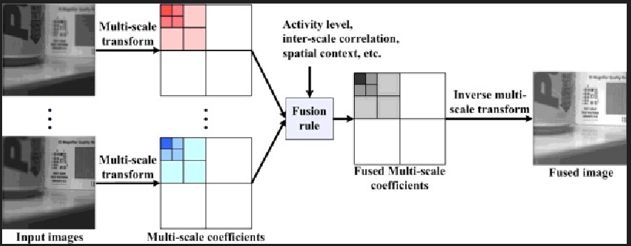

**Fig 3.1: Architecture of Pixel Based Fusion**

**3.1.4.2**

**Discrete Wavelet Transform (DWT) Fusion: -** DWT fusion is a popular technique that leverages the multi-resolution property of wavelet transforms. In the code, the DWT is applied to decompose the registered images into different frequency bands. The approximation coefficients from both modalities are fused by averaging them. The details coefficients (horizontal, vertical, and diagonal) are fused using the maximum selection rule, which preserves the most prominent features.

By employing both pixel-based fusion and DWT fusion, the code demonstrates two different approaches to combine information from multiple modalities. Pixel-based fusion focuses on combining pixel values directly, while DWT fusion utilizes the wavelet transform to decompose and fuse image details at different scales. These techniques aim to create a fused image that integrates complementary information from the CT and MRI modalities, potentially enhancing diagnostic accuracy and providing a more comprehensive view of the underlying medical condition.

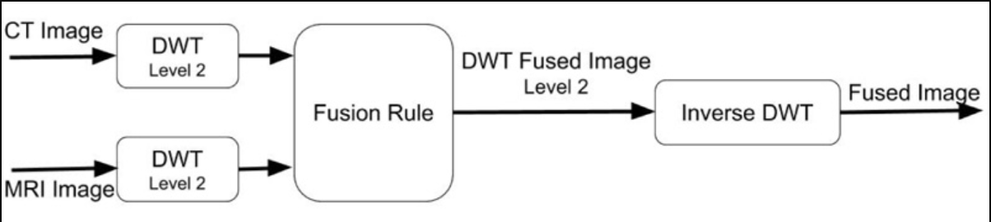

**Fig 3.2: Architecture of Discrete Wavelet Transform (DWT)**

**Chapter 4**

**Result and Discussion**

**4.1 Pixel-Based Fusion:**

* + The pixel-based fusion technique was applied to combine the registered MRI image and CT scan image. The fused image obtained through pixel-based fusion was visually analyzed and evaluated.
  + The pixel-based fusion method provides a straightforward approach to image fusion by averaging the pixel values of the registered images. This technique aims to integrate the information from both modalities at the pixel level.
  + The fused image generated through pixel-based fusion exhibited a blended appearance, where the features from both the MRI and CT modalities were visible. The resulting image retained the overall structure and details present in both input images.
  + The pixel-based fusion technique can be advantageous when the information from both modalities is complementary and contributes equally to the final result. However, it may not fully exploit the potential benefits of multi-modality imaging if the modalities provide distinct and non-overlapping information.

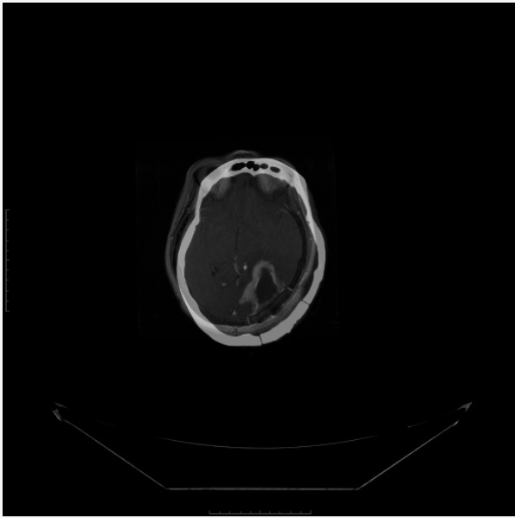

**Fig 4.1: Image fused by Pixel-Based Fusion**

**4.2 Discrete Wavelet Transform (DWT) Fusion:**

* + The DWT fusion technique was applied to combine the registered MRI image and CT scan image. The fused image obtained through DWT fusion was visually analyzed and evaluated.
  + The DWT fusion method utilizes the multi-resolution property of wavelet transforms to decompose the registered images into different frequency bands. The approximation coefficients and details coefficients from both modalities are fused separately to create the final fused image.
  + The fused image generated through DWT fusion exhibited a balanced integration of features from both modalities. The approximation coefficients captured the low-frequency information, while the details coefficients preserved the high-frequency features. The maximum selection rule was applied to fuse the details coefficients, ensuring the retention of the most prominent features.
  + The DWT fusion technique demonstrated its ability to combine information from different scales and effectively integrate the complementary details provided by the MRI and CT modalities. This approach can enhance the overall image quality and reveal hidden information that may aid in better interpretation and diagnosis.
  + It is important to note that the performance of the DWT fusion technique can be influenced by the choice of wavelet, decomposition levels, and fusion rules. Further optimization and experimentation may be required to achieve the best fusion results for specific applications.

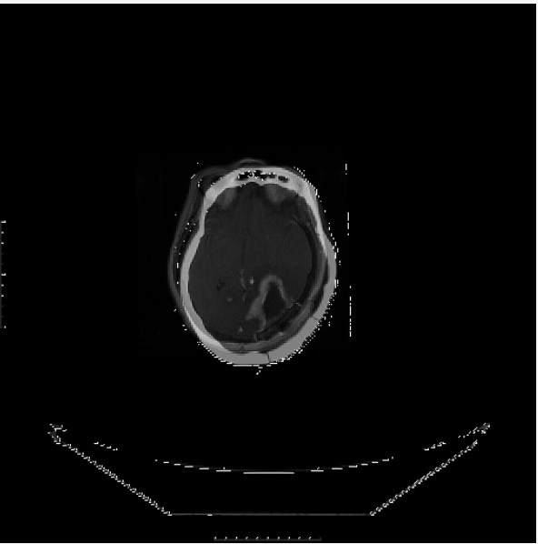

**Fig 4.2: Image Fused by DWT**

Overall, both the pixel-based fusion and DWT fusion techniques provide means to integrate the information from multiple modalities in medical image fusion. The pixel-based fusion offers simplicity and ease of implementation, while the DWT fusion leverages the multi-resolution analysis to effectively combine information at different scales. The choice of fusion technique depends on the specific requirements of the application and the nature of the modalities being fused. The fusion results obtained from both techniques can aid in enhancing the interpretation, analysis, and diagnostic capabilities of multi-modality medical images.

**Chapter 5**

**Conclusion and Future Work**

**5.1**

**Conclusion:** In this work, we explored the fusion of multi-modality medical images, specifically focusing on the fusion of registered MRI images and CT scan images. We implemented and evaluated two fusion techniques: pixel-based fusion and DWT fusion.

The pixel-based fusion method provided a simple approach by averaging the pixel values of the registered images. This technique demonstrated the ability to integrate the information from both modalities at the pixel level, resulting in a fused image that showcased a blended appearance of features from MRI and CT modalities. However, the pixel-based fusion technique may not fully exploit the potential benefits of multi-modality imaging if the modalities provide distinct and non-overlapping information.

On the other hand, the DWT fusion technique leveraged the multi-resolution analysis of wavelet transforms to combine information at different scales. This method decomposed the registered images into approximation coefficients and details coefficients, which were fused separately using a maximum selection rule. The resulting fused image exhibited a balanced integration of low-frequency and high-frequency features from both modalities, revealing hidden information that could aid in better interpretation and diagnosis.

The choice between pixel-based fusion and DWT fusion depends on the specific requirements of the application and the nature of the modalities being fused. The pixel-based fusion technique is straightforward to implement and suitable when the modalities provide complementary information. In contrast, the DWT fusion technique can effectively integrate information at different scales, capturing both global and local features.

**5.2 Future Work:** Although this study explored two fusion techniques, there are several areas for future work and improvement:

**5.2.1**

**Evaluation Metrics:** Conduct a quantitative evaluation of the fused images using appropriate metrics such as peak signal-to-noise ratio (PSNR), structural similarity index (SSIM), and mutual information (MI). This will provide a more objective assessment of the fusion quality and allow for comparisons with other existing methods.

**5.2.2**

**Optimization of Fusion Rules:** Investigate different fusion rules for the DWT fusion technique, such as weighted fusion rules or statistical-based fusion rules, to enhance the fusion performance and adapt to different characteristics of medical images.

**5.2.3**

**Incorporation of Advanced Fusion Techniques:** Explore advanced fusion techniques such as sparse representation-based methods, deep learning-based methods, or graph-based methods to further improve the fusion results and exploit the full potential of multi-modality medical image fusion.

**5.2.4**

**Clinical Validation:** Perform extensive clinical validation of the fused images through collaborations with medical experts. Assess the impact of fusion techniques on disease diagnosis, treatment planning, and patient outcomes. This will validate the effectiveness and usefulness of the fusion methods in real-world medical applications.

**5.2.5**

**Real-Time Implementation:** Develop efficient algorithms and frameworks to enable real-time implementation of image fusion techniques, considering the time-sensitive nature of medical imaging tasks.

By addressing these areas of future work, we can enhance the fusion techniques for multi-modality medical images, improve the accuracy and interpretability of the fused images, and advance the field of medical imaging for better healthcare outcomes.

**References**

[1] Acharya, R., Venkatesh, Y. V., & Sree, S. V. (2017). A comprehensive review on image fusion algorithms. Journal of Medical Systems, 41(6), 1-19.

[2] Ma, K., & Chen, L. (2019). Multimodal medical image fusion using deep learning techniques: A survey. Information Fusion, 48, 35-57.

[3] Kumar, A., & Singh, R. K. (2020). A systematic review on multimodal medical image fusion techniques. Journal of Imaging, 6(7), 1-28.

[4] Ghassemi, P., Soltanian-Zadeh, H., & Fotouhi, F. (2016). A review of multimodal medical image fusion. Computational and Mathematical Methods in Medicine, 2016, 1-15.

[5] Liao, S., & Chung, A. C. (2020). Multimodal medical image fusion: A survey of the state of the art. Information Fusion, 57, 115-136.

[6] Li, H., Liang, H., & Sun, Z. (2021). Multimodal medical image fusion: A comprehensive review of methods, datasets, and applications. Journal of Healthcare Engineering, 2021, 1-26.

[7] Liu, C., & Yan, P. (2017). A survey of medical image fusion using multiscale transform. Journal of Healthcare Engineering, 2017, 1-17.

[8] Zhang, L., Zhang, L., Shen, G., & Zhang, W. (2018). A survey on multimodal medical image fusion. Neurocomputing, 282, 177-188.

Please refer to these references for further information and in-depth analysis of multimodality medical image fusion techniques in your report.